

INSTALLATION PROCEDURE OF EQOBRUSH

FOR HEAT EXCHANGERS AND CONDENSORS

PROJECT: P T. TOYOTA MOTOR MFG INDONESIA

PROJECT No.: 7670

**Table of Content**

INTRODUCTION **3**

MATERIAL CHECK **3**

1. **INSTALLATION OF SOCKETS, BASKETS & BRUSHES 4**

PROCEDURE 4

FINISHING 7

1. **REMARKS ON INSTALLATION OF VALVE 8**
2. **INSTALLATION OF CONTROL PANEL 9**

Appendices:

* Wire diagram

**INTRODUCTION:**

To start the installation of the brush-cleaning-system the heat exchanger’s interior must be reachable without covers. If on height, the owner must place a safe scaffolding to reach the pipe plates.

Consider safety of installation staff by making sure:

* Working space is safely accessible
* Workers are secured when working on scaffolding or heights
* Sufficient light in the working area to ensure safety and quality of work
* Arrange for proper ventilation

**MATERIAL CHECK:**

* Check if the BILL OF QUANITY (BOQ) matches with the heat-exchanger.
* Confirm the Packing list details with the BOQ. The provided components basically consist of following components:
  + Baskets and brushes
  + Reversing valve
  + Actuator (geared drive for reversing valve)
  + Position switch
  + Control panel
  + Utility materials (fasteners, cement, cups)
* Check the pipe end with a socket if the sizing is correct. The socket end must go smooth in the pipe and stop at the first ring on the socket.
* Check the brush size by putting one brush in a pipe. The brush hair must be slightly oversized to the inner pipe diameter.



NOTE – IMPORTANT

Make sure all electrical installation works are executed by qualified electrical installation personnel only.

**SECTION 1: INSTALLATION SOCKETS, BASKETS & BRUSHES**

**NOTE:**

Instructions to be followed carefully to avoid performance loss! We recommend owner’s verification of the quality of the socket installation. Glue residues will obstruct brushes which in turn lead to non-treated (dirty) pipes and possible unnecessary pressure losses in the operation.

Condenser covers need to be removed to allow proper installation. Do not install through pipe openings of the condenser. Quality of installation cannot be guaranteed and brushes may get stuck or may fall off in operation, which will affect performance of the condenser.

Pictures of properly installed baskets are required for the commissioning document.



**UNIT PREPARATION:**

The sockets will be glued in the pipes end with special metal cement.

**Therefore, ALL pipe-ends need to be free from burrs and grease or oil. Before starting the pipe-ends need to be extra cleaned with P-C-444 Cleaning Compound, Solvent Soluble, Grease Emulsifying or equivalent cleaning compound.**

The purpose of cleaning compounds is to remove oil, grease and other foreign matter from pipe ends to ensure good contact between the cement and the inner pipe wall.

**PROCEDURE:**

The brushes, sockets and baskets cleaning cloth, cement, paper cups and application brushes are all provided with the system components. The cleaning solvent needs to be supplied by the owner.

**For retrofit, proper mechanical cleaning is required before the installation can commence!**

The cement will remain processable for 30 to 45 min. Prepare small portions (according to cup size) to have smooth cement available at all times throughout the installation process. We therefor recommend to carefully plan cycles of installation when working with smaller teams.

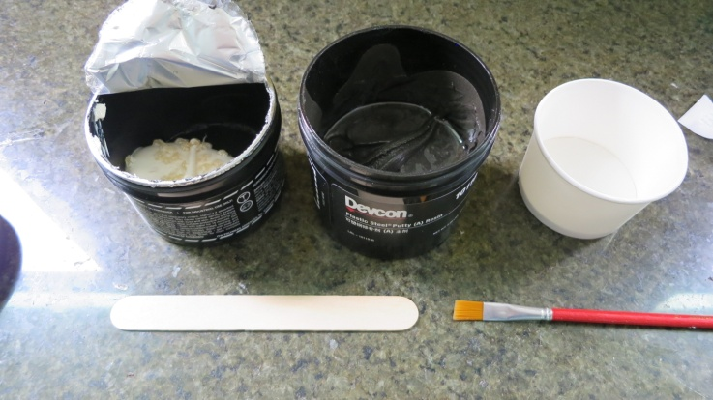

Step 1) Mix ¾ of black cement with ¼ white hardener and stir it properly with the supplied spatula.

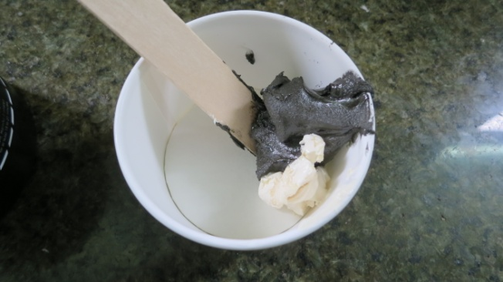

Step 2) Stir till you have a coherent mass. Due to the chemical reaction the cement warms up.

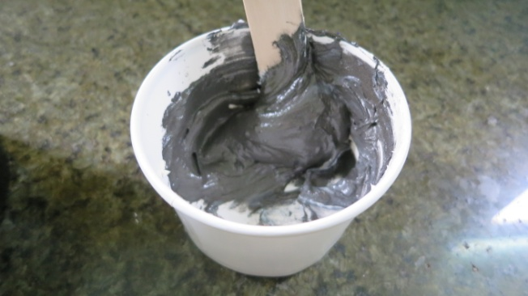

Step 3) With the brush supplied put a thin layer of glue on the ringed end of the socket. Make sure all rings are covered in cement.

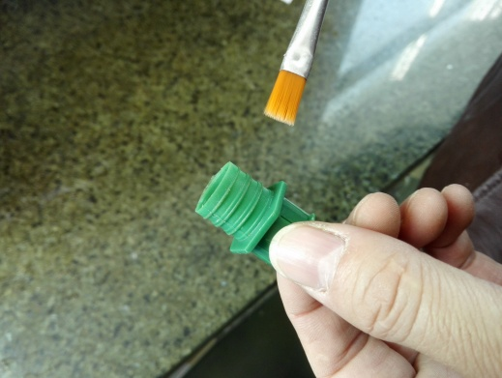 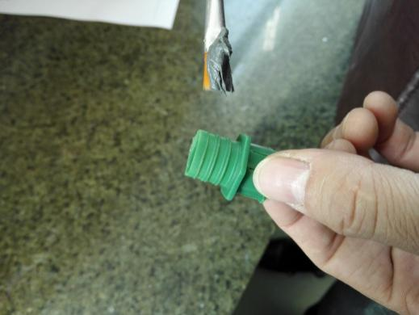

Cement brush and socket Cement on brush

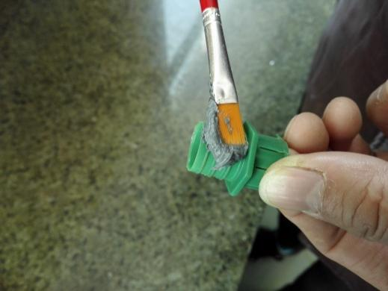 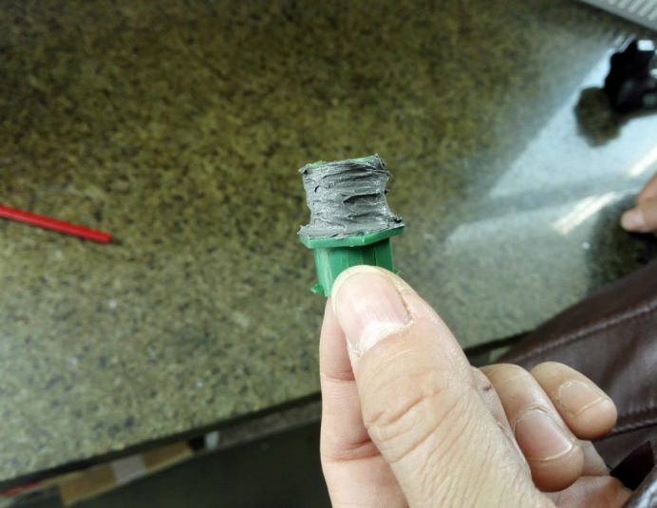

Apply cement on socket Socket with cement layer

Step 4) Make sure that there is no glue inside the brush channel. Remove glue from inside of brush channel.

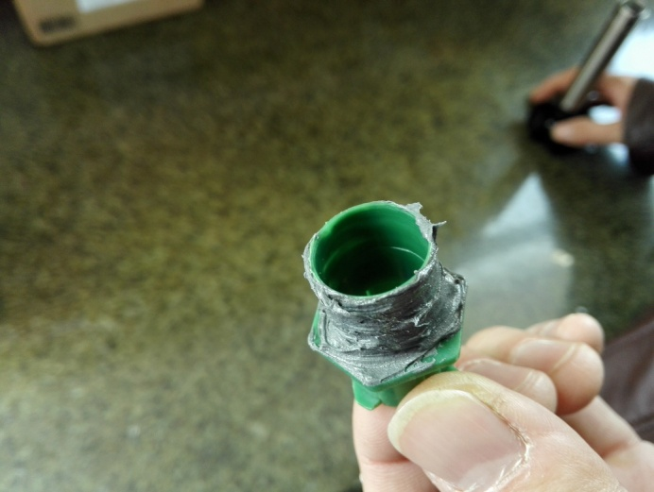 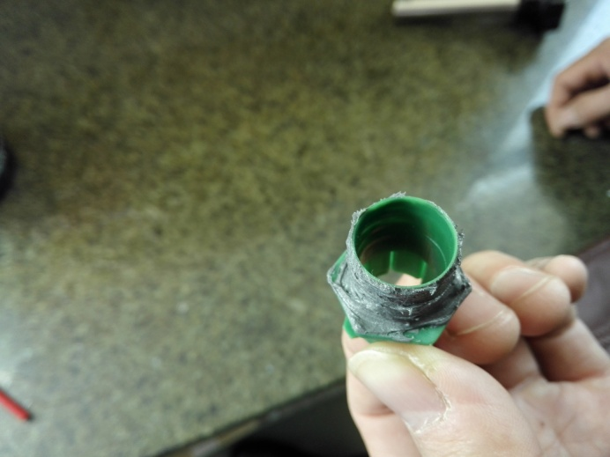

Step 5) Place the socket on the hand tool. Push-in the socket into the pipe plate.

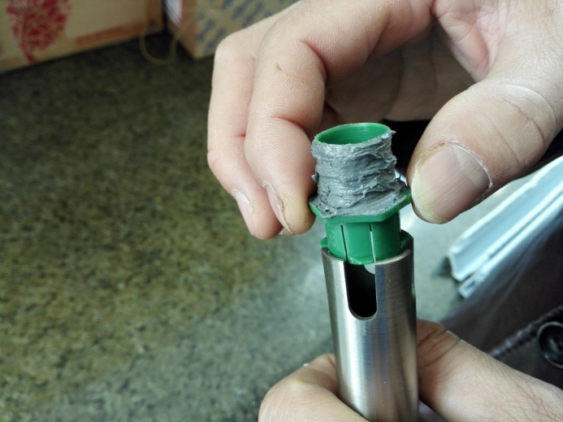 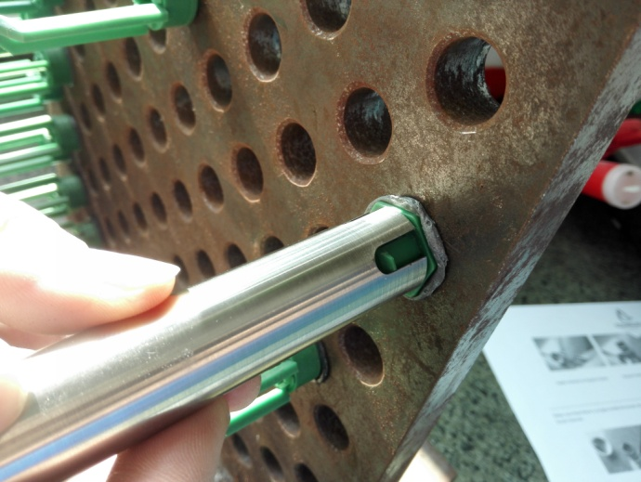

A cement ring forms around the holder.

**FINISHING:**

Once all the sockets are in place, put in the brushes at one end. ONE brush for each pipe.

Once all the brushes are in place put on the basket and check that every socket, brush and basket is placed properly.

The cement needs about 24 hours to cure before the heat-exchanger can be used.

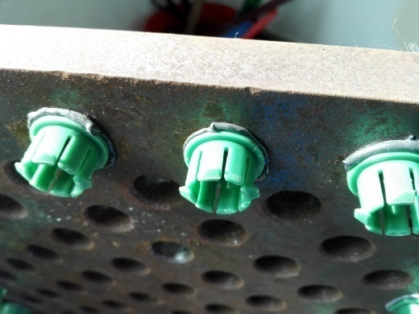 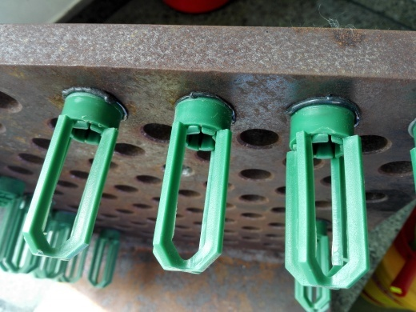

Well glued socketsPut on the basket

**SECTION 2: INSTALLATION OF THE FLOW REVERSAL VALVE**

**INSTRUCTION AND REQUIREMENTS OF VALVE**

The valve should be installed in the piping system as per drawings provided. Any type of structure to support the valve body may be added.

The bottom or back side of the valve (the side that connects to heat exchanger/condenser) can be installed in the pipe work without extra precautions, while the top or front side of the valve (at the cover flange where actuator is to be installed) the piping **MUST BE INSTALLED WITHOUT STRESS OR ANY FORCES ON THE VALVE BODY**. Rubber compensators that are supplied (2) with the units should be installed in the piping to the valve (actuator side)

Demountable pipe section at the inlet and outlet from the valve-front is required.

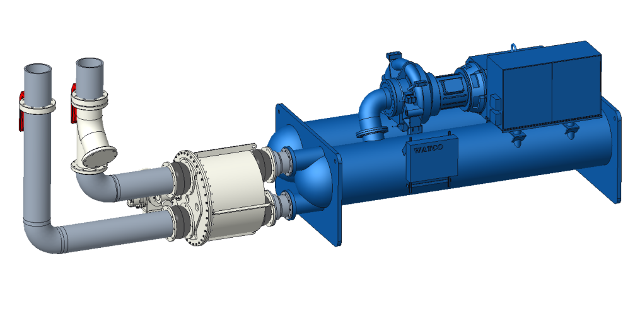

**Reversal valve installed at horizontal position**

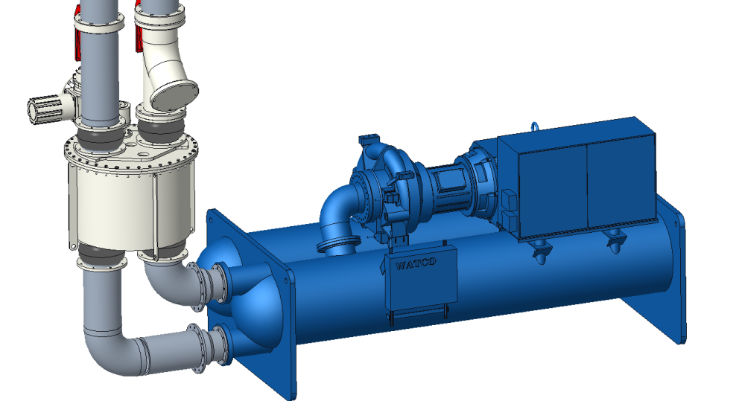

**Reversal valve installed at vertical position**

**Reversal valve installation Do’s and Don’t:**

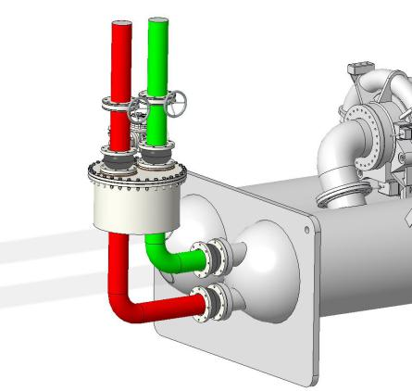

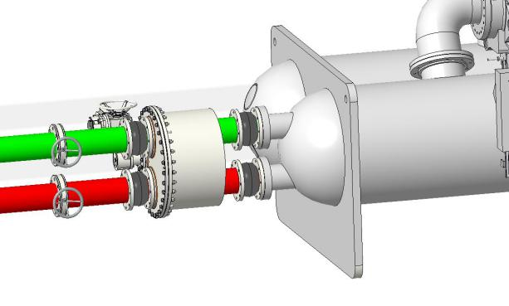

√

√

**Properly installed. Compensators in and butterfly valves in the correct position. No pressure is exerted on the Flow Reversal Valve when the butterfly valves are closed.**

×

×

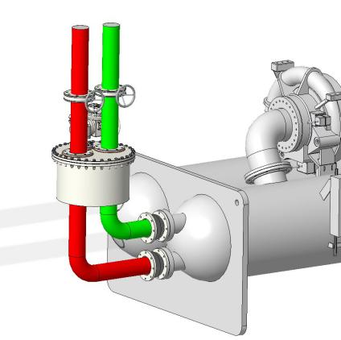

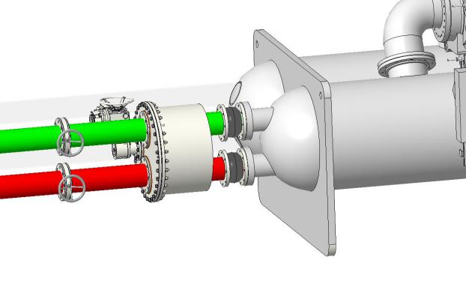

**Compensators on actuator side (front side of valve) are missing which may lead to valve cover leakage due to piping tension.**

**Butterfly valves in the correct position.**

×

×

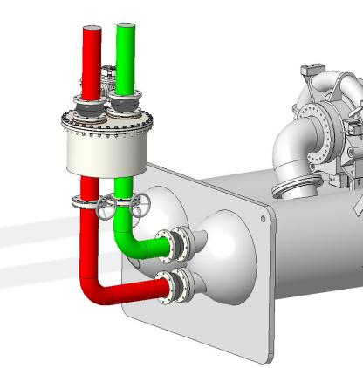

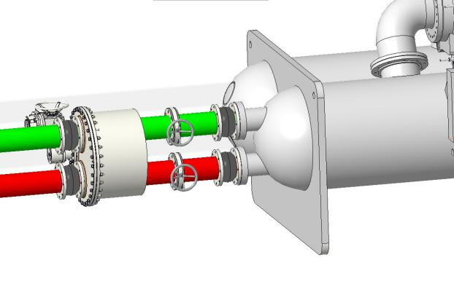

**Butterfly valves cannot be installed between the Flow Reversal Valve and the condenser. When the valves are closed, the pressure difference may damage the internal seal which can cause cross-over. This will impact chiller performance.**

**Compensators are installed correctly.**

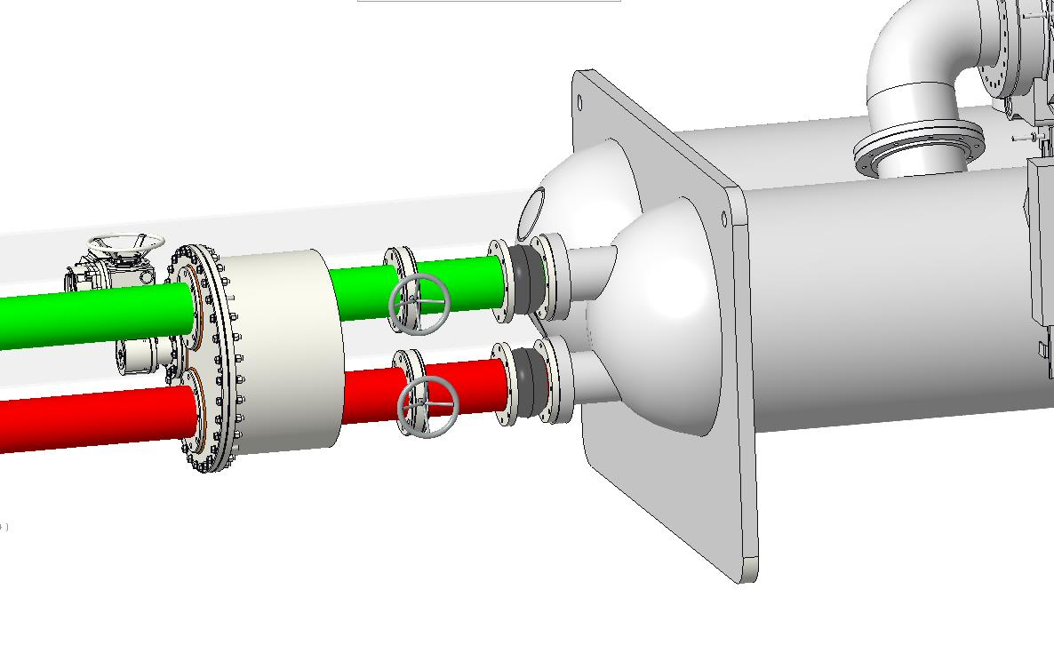

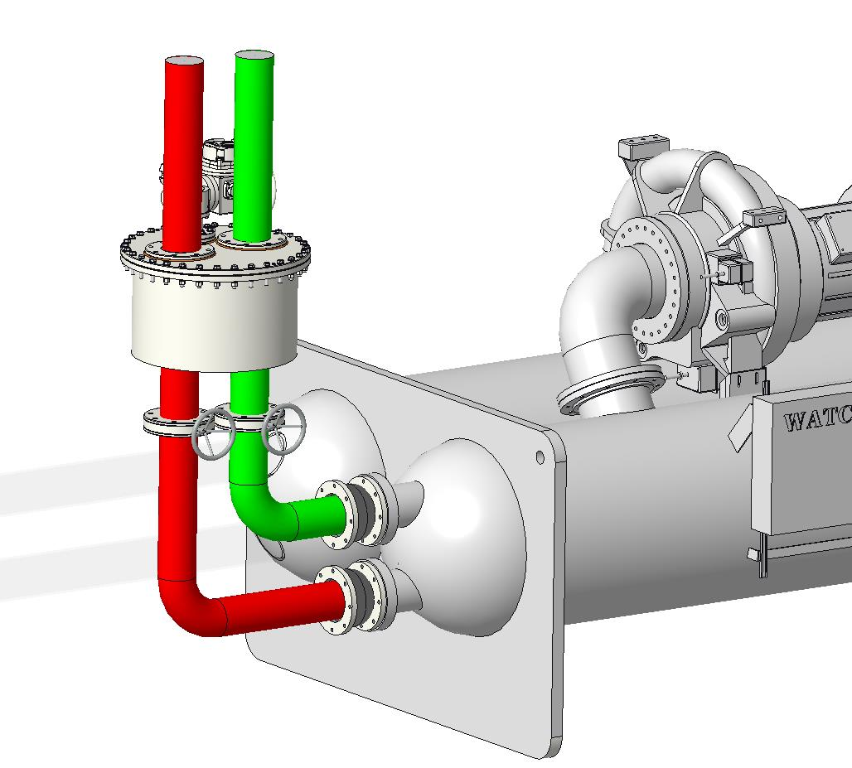

×

×

×

**Butterfly valves are not in the correct position. Compensators on front side are missing.**



**Excluded from warranty are damages related to:**

* Exceeding **maximum allowable** water flow as in table below.
* Incorrect mounting of flow reversal valves (Pipe tension, insufficient support, welding on valve body, absence of flexible compensators.)
* **Absence of strainers** in the pipework to the flow reversal valves.

|  |  |  |  |  |  |  |  |  |  |
| --- | --- | --- | --- | --- | --- | --- | --- | --- | --- |
| Valve size | KV150 | KV200 | KV250 | KV300 | KV350 | KV400 | KV450 | KV500 | KV600 |
| Max Flow in m3/hr. | 160 | 280 | 440 | 630 | 860 | 1,130 | 1,430 | 1,760 | 2,540 |

**SECTION 3: INSTALLATION PLC CONTROL PANEL**

Install the panel according the given electrical details and apply the power lines as well the connection of the motor to the panel (R-S-T-0-GR) and the position indicator (8 x 0.75 mm2).

Confirm that the control panel receives power.

**Actuator & Position Indicator:**

Connect the cables according the diagram (appendix 1) and check if power is brought to the panel.

**WARNING**: Do not stick any body parts into the reversing valve when actuator is powered

After actuator and position indicator are properly mounted and all wirings are connected according to the diagram, follow below steps to adjust position indicator which controls the initial alignment position of valve inlet/outlet holes and swing box hole of the valve.

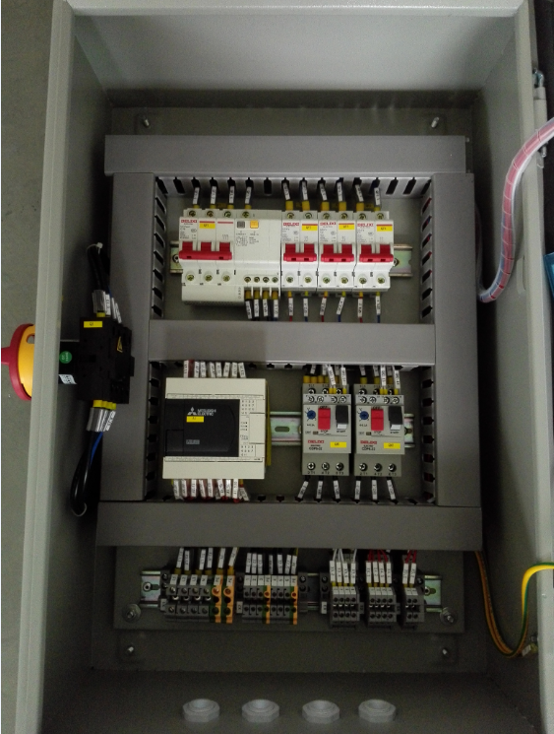

The PLC control panel (5 valve-set up)