OPERATION MANUAL OF EQOBRUSH
FOR HEAT EXCHANGERS AND CONDENSORS

PROJECT: P T. TOYOTA MOTOR MFG INDONESIA
PROJECT No.: 7670

Table of Content

- START-UP / OPERATION / MAINTENANCE 3
- START UP 3
- AUTOMATIC OPERATION 4
- SERVICE AND MAINTENANCE 4
      - BRUSH AND BASKET 4
      - VALVE AND ACTUATOR 4
- NOTES TO OPERATOR 4
- SAFETY FEATURES 5
- MOTOR CURRENT CONTROL 5
- RUN TIME CONTROL 6

SECTION 1: START-UP / OPERATION / MAINTENANCE

1) START-UP

To start up the water system follow the instructions from the chiller/heat exchanger.
Make sure the valve and flange connections do not leak and that there are no air pockets in the pipe work. (Install deaeration valves there where necessary).
Once the system pump(s) is running for a while, the first cleaning cycles can be activated manually.
Monitor the valve behavior during operation and confirm that the swing box runs smoothly. If not, there may still be air pockets in the system. Let the pumps run for a while till all air pockets are filled.

STEP 1:
Before electrical activation, the valve should be operated manually to see if the valve travel is free and smooth. Putting down the hand lever and turn the valve by hand into the reversal position and back. If the runway is smooth the panel can be activated.

STEP 2:
Set the switch on the actuator to “LOCAL”. Then activate a cleaning cycle by turning the function knob to “close” direction. Once arrived, turn the function knob to “open” direction. The valve travel should be smooth.
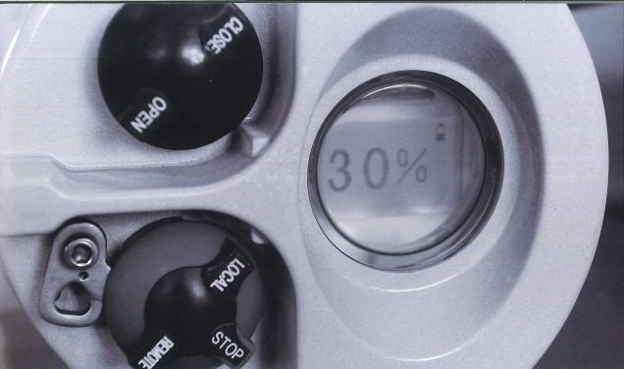

STEP 3:
Set the switch on the actuator to “REMOTE”. The panel will activate the actuator.
Lock the function switch so that it is non-turntable.

STEP 4:
Activate a few manual cleaning cycles by pushing the green function light button on the panel. Also, now the valve should run smoothly.

The actuator is fully switched off if the function knob in locked in “STOP” position.

2) AUTOMATIC OPERATION
Once the power is activated and the system runs smoothly, every 4 hours there will be an automatic cleaning cycle. The time of the cycle is stored in the PLC history.

3) SERVICE AND MAINTENANCE
Brushes and Baskets
The system is maintenance free and runs 1 to 2 years without any attention.
Every 2 to 5 years the heat exchanger heads should be opened to check the condition of the pipes, brushes and baskets.
Replace internal components if required.
Valve and Actuator
The actual running time of the actuator is quite limited: +/- 2 minutes a day or +/-12 hours per year.
An oil replacement in the actuator is advised every 2 years depending on the ambient conditions of the valve/actuator set. Contact WATCO for more details.

4) NOTES
EQOBRUSH avoids fouling and scaling deposits to settle in the heat exchanger/condenser pipes. However, EQOBRUSH does not remove deposits in pipes that have already hardened.
Install after cleaning or on new equipment
It is therefore strongly recommended to install the units only on clean heat exchanger systems (either immediately after manual cleaning or on new equipment).

Operate only with active EQB-reversing valve
We also recommend not running the heat exchanger system without activating the reversing valve over periods longer than 12 hours as this may allow calcium deposits to deposit and harden.

Heat Exchanger when not in use
During periods when Heat Exchanger or Condenser is not in use we recommend to:
- Keep system (Heat Exchanger and Reversing Valve) filled with water
- Do not stop the reversing valve from moving in its set interval. This will minimize risk of valve getting stuck in its position over prolonged period of time
Water inlet strainer
To remove possible foreign objects obstructing the valve it is necessary to disconnect the piping, hence this requires a stop of the installation. We suggest regular checking to prevent this (mostly caused by defect strainers at the water inlet) from happening.

Placement of control panel
The EQOBRUSH system can operate completely independent and does not interfere with any of the thermal systems connected to the heat exchanger or condenser. It is therefore not necessary to connect to other operational control systems in use. However, we do strongly recommend installing the control panel in a location where it is clearly visible to the operating staff as to ensure any blinking alarm to be visible.
SECTION 2: SAFETY FEATURES

- Motor Current Control.
Every valve has a dedicated over current relay installed in the control panel.
In case the swing box is obstructed (by external objects in the valve for example) during its movement, the increased power consumption in the actuator will trigger the swing box to return to its starting position (either operational or cleaning position). The alarm light will blink and the system needs to be reset for it to resume operations.
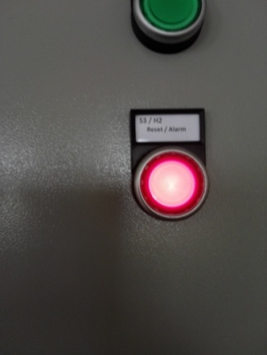
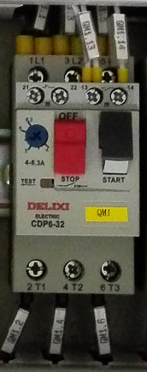
Reset of the alarm by releasing
the over-current relay:
- ??
- ??

If the problem persists it may be necessary to remove the feed pipes from the front of valve and check for debris blocking the swing box.

- Time Control.
The run time is the time the swing box needs to travel from start to end position. The maximum run time is set in the PLC.
Run time is different for each valve size and is pre-programmed into PLC.

If the actual run time is longer than the programmed one, the safety control function will run the swing box back to its starting position and trigger the alarm.

The system needs to be reset for it to resume operation.

If the problem persists it may be necessary to remove the feed pipes from the front of valve and check for debris blocking the swing box.

REMARKS:

If EQOBRUSH is operated on chillers running at top load, it might occur that they trip on high pressure. This depends on the chiller brand and the design of the circulation system. In general, there are 3 solutions:

A: The time in flush position is standard 10 to 15 seconds. This might be too short in a certain mode of operation. The flush time can then be extended to 60 or 90 seconds.

B: The cleaning cycles to be chosen at the down time of the chiller, e.g. several cleanings in the morning before the peak load comes up, and several cleanings after the peak load is dissipating at the end of the day.

C: Use a signal from the EQOBRUSH PLC to run down the load to <60% 5 minutes before the cleaning cycle starts. After the cleaning cycle is finished, the chiller can be operated at the required load again. This session might take up to max. 10 minutes.

All these functions are programmable in the PLC.

